Registering Your Program and Reporting Your Success
- Register Your PTA – by October 31st for Georgia PTAs
- Visit PTA.org/Reflections, click “Register My PTA” and enter your PTA’s 8-digit ID number.
- Enter your PTA Name, City, State, ZIP.
- Enter you PTA Leader Name, Title, Address, City, State, ZIP.
- Enter your School Name, Number of Students Enrolled, Title I Status (Y/N), Percent of students who receive free/reduced priced lunches.
- Enter additional contacts who wish to receive program communications from State and National PTA.
- Click “Submit” and receive a confirmation picture below.

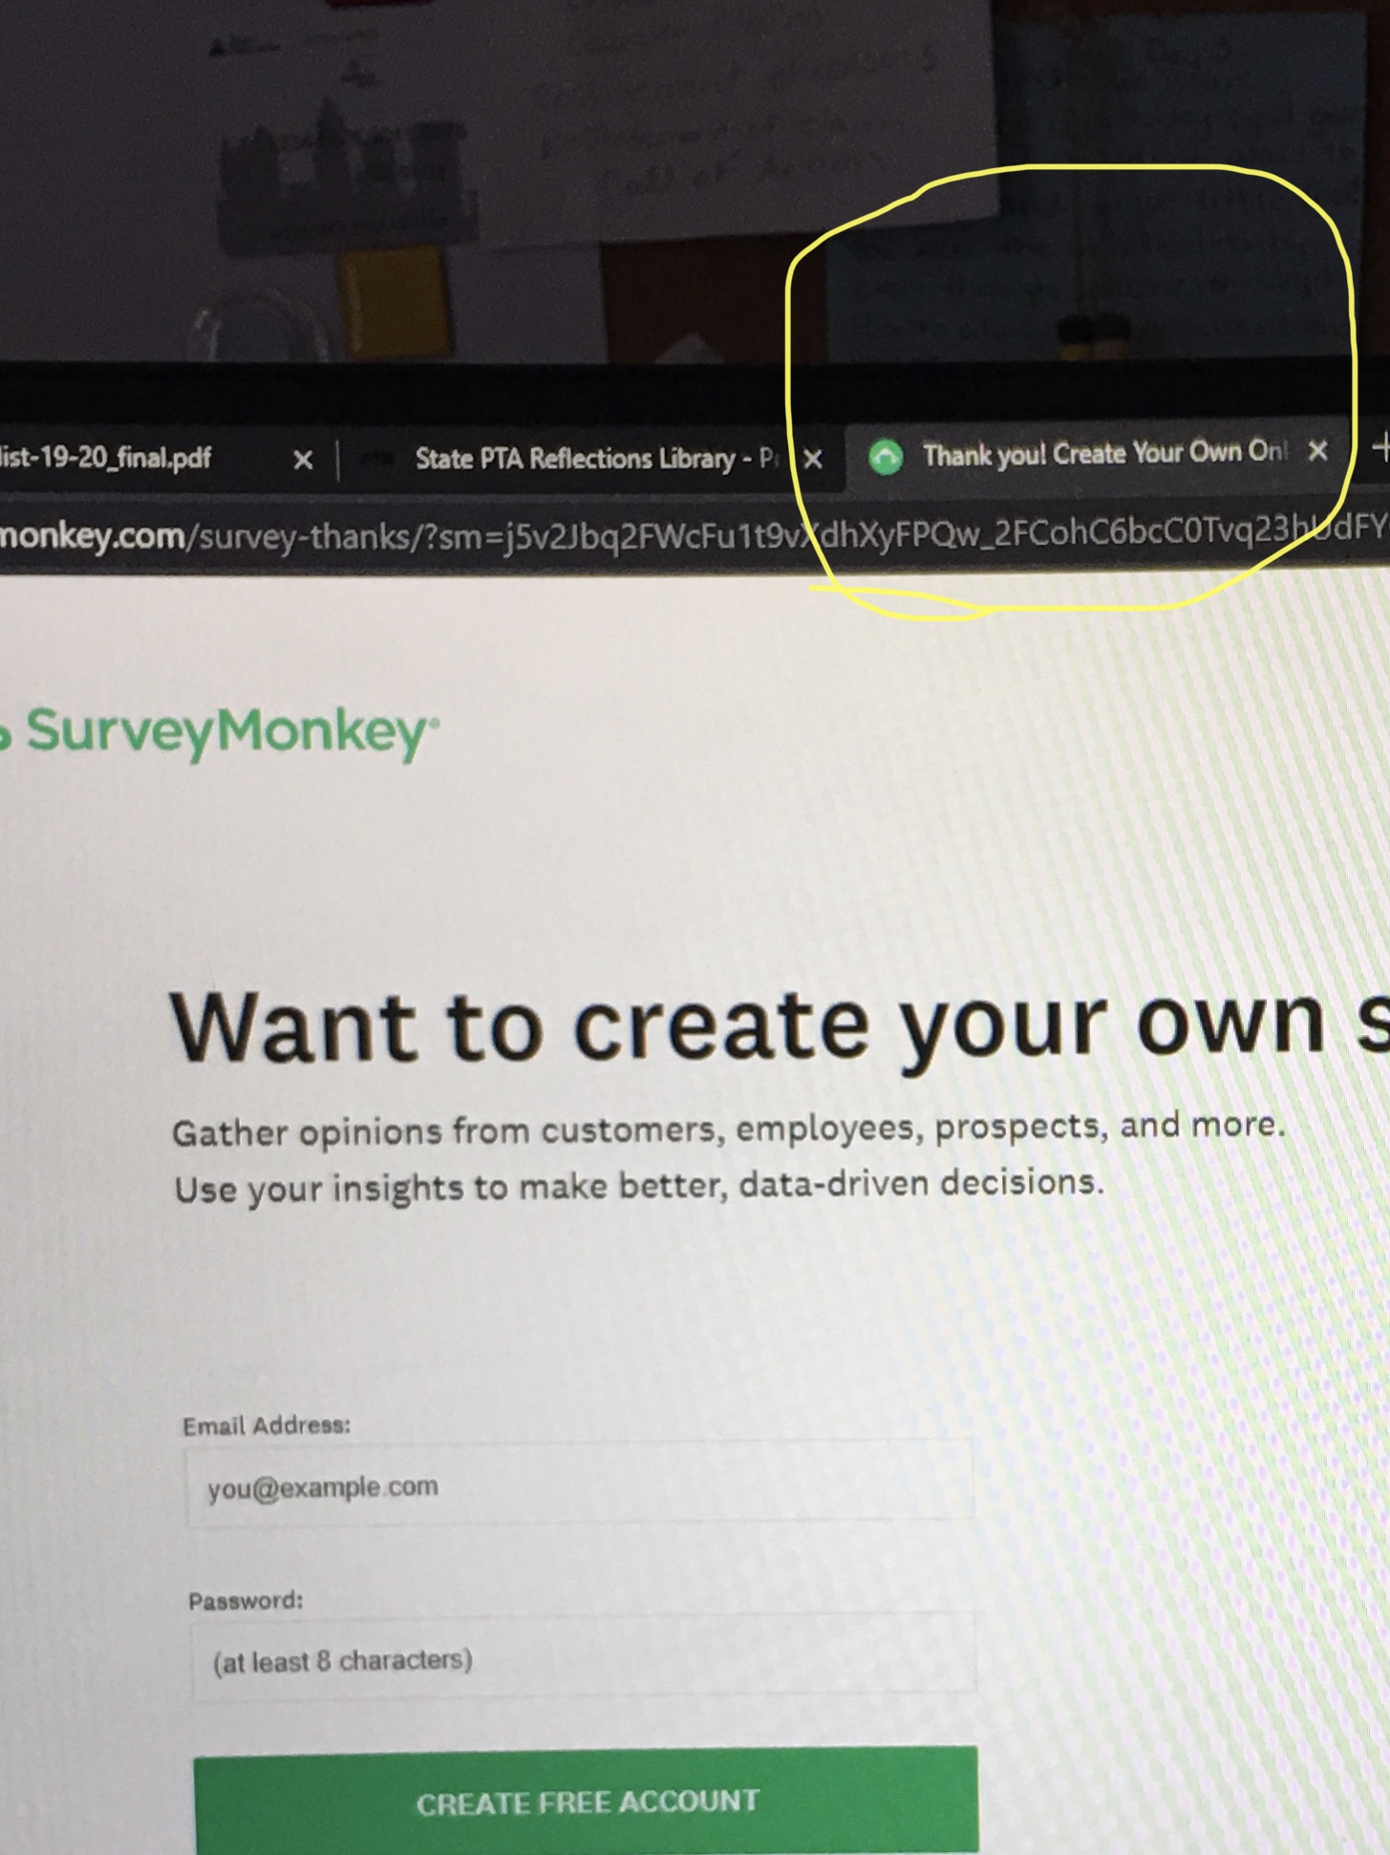

Using the Student Entry Portal
- Create an Account.
- Visit PTA.org/Reflections and click the “Student Entry Portal” button.
- Click “sign up” and enter your full name, email and create a password.
- Click “register” and receive a confirmation email.
- Click the unique link in your confirmation email to activate your account.

- Submit Advancing Student Entries.
- From your account’s home page, click “create a submission” for each student entry advancing to the next round.
- Click “Entry Form” and enter the student entry form.
- Click “Upload Artwork” to upload a digital copy of the entrant’s work.
- Click “submit entry” to finish. Double check your work as submission cannot be edited. To report errors/edits, please email your State PTA.

- Confirm Student Submission Status.
- Click “home” to view a list of created submissions. Confirmed submissions will show a status of “Submitted.”
- Check your email for a copy of your submitted entry form.
- Don’t forget to follow all submission requirements and deadlines provided by your State PTA.
- Look for State and National PTA award announcements and special invitations to Reflections celebration events.

